**Siddhant Mundhe**

**Data engineering batch 1**

1)Inner Join

- The inner join is used to select all matching rows or columns in both tables.

-Retrieve information about submissions along with the corresponding user and challenge details.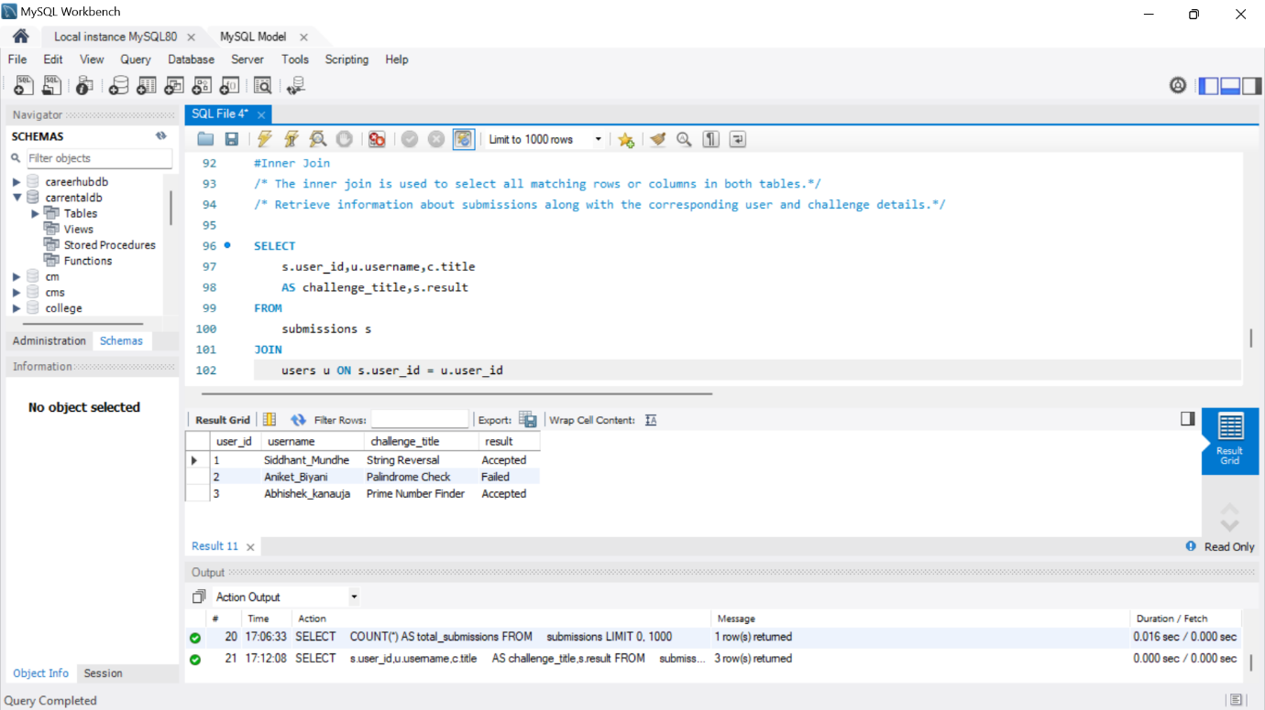

2)Left Join/Left Outer Join

- The LEFT JOIN is used to retrieve all records from the left table and the matched rows or columns from the right table.If both tables do not contain any matched rows or columns, it returns the NULL.

-Finds all users along with their submissions, even if they haven't submitted any challenges.

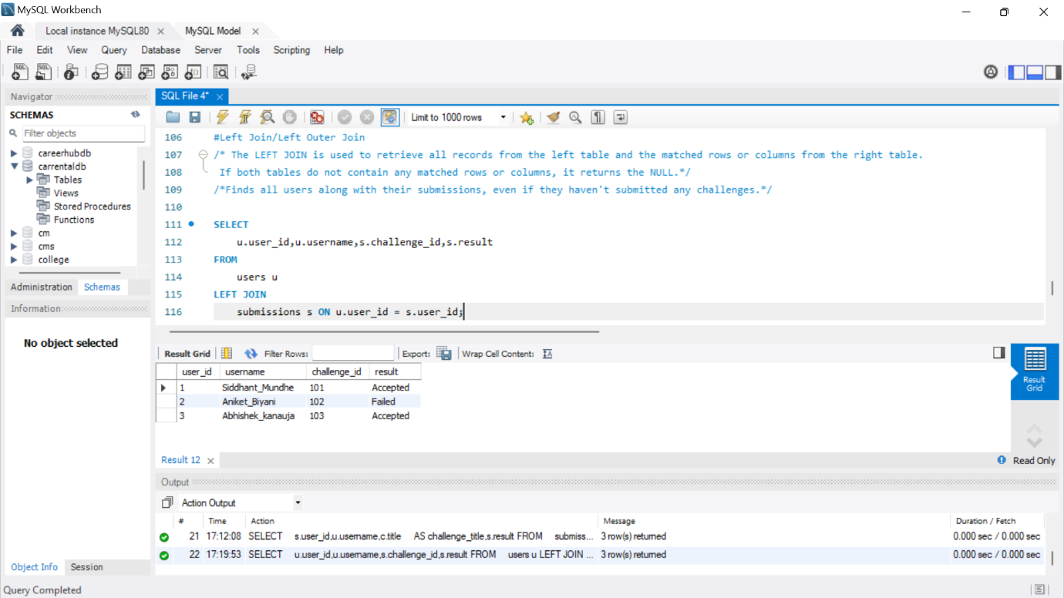

3)RIGHT JOIN/RIGHT Outer JOIN:

-The RIGHT JOIN is used to retrieve all records from the right table and the matched rows or columns from the left table. If both tables do not contain any matched rows or columns, it returns the NULL.

-Finds all challenges along with the submissions, even if there are no submissions for some challenges.

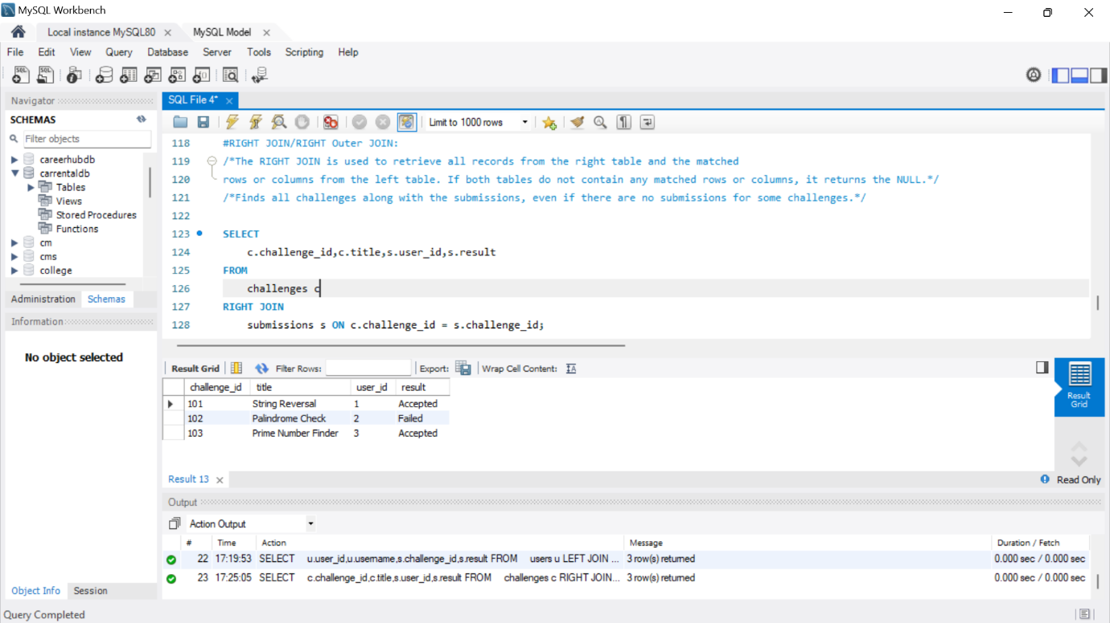

4)FULL JOIN/FULL Outer JOIN:

-It is a combination result set of both LEFT JOIN and RIGHT JOIN. The joined tables return all records from both the tables and if no matches are found in the table, it places NULL. It is also called a FULL OUTER JOIN.

-Retrieve all users and challenges along with their submissions.

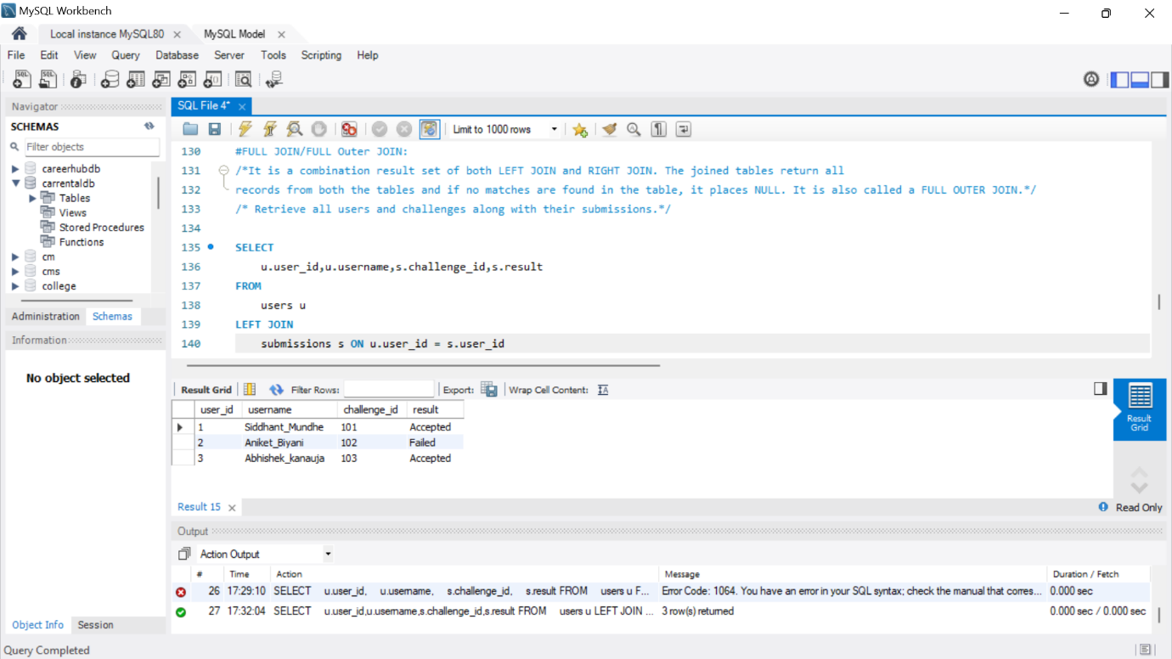

5) CROSS JOIN

It is also known as CARTESIAN JOIN, which returns the Cartesian product of two or more joined tables. The CROSS JOIN produces a table that merges each row from the first table with each second table row.

